Review about git

How to config Git Proxy

1. Download Git Portable (Because Bosch didn’t give u permission to install) from

[https://**git**-scm.com/](https://git-scm.com/)

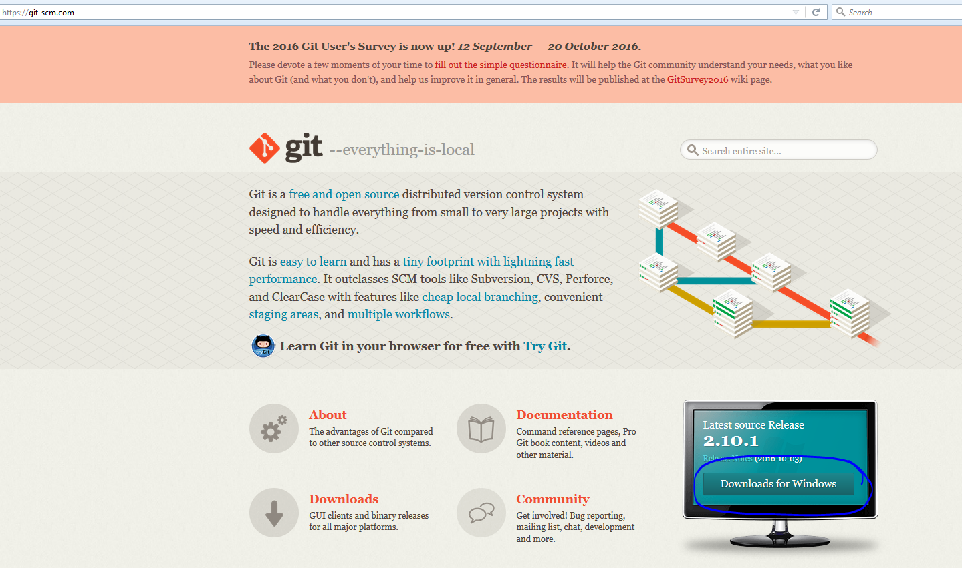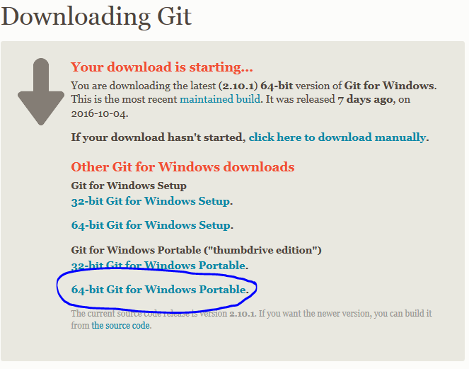

1. Run git-cmd.exe or git-bash.exe in the git portable ‘s extract folder



1. Run this command to set proxy for your computer

**Git config –global http.proxy http:/UserID:Pass@rb-proxy-de.bosch.com:8080**

UserID: your userID which you use it to login your computer

Pass: Your password

1. Go back to the TFS and get your git clone link

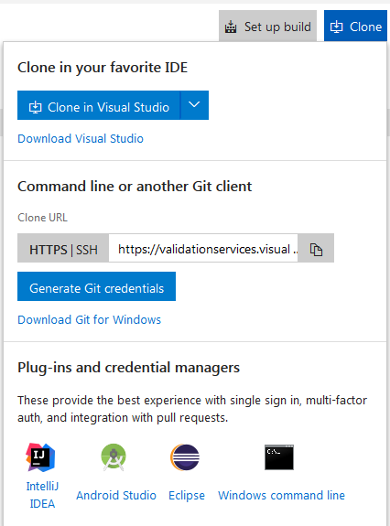

1. Come back to your git-cmd.exe and run the command below

Git clone [Paste your git clone here with out quote] then enter